**Task 1:**

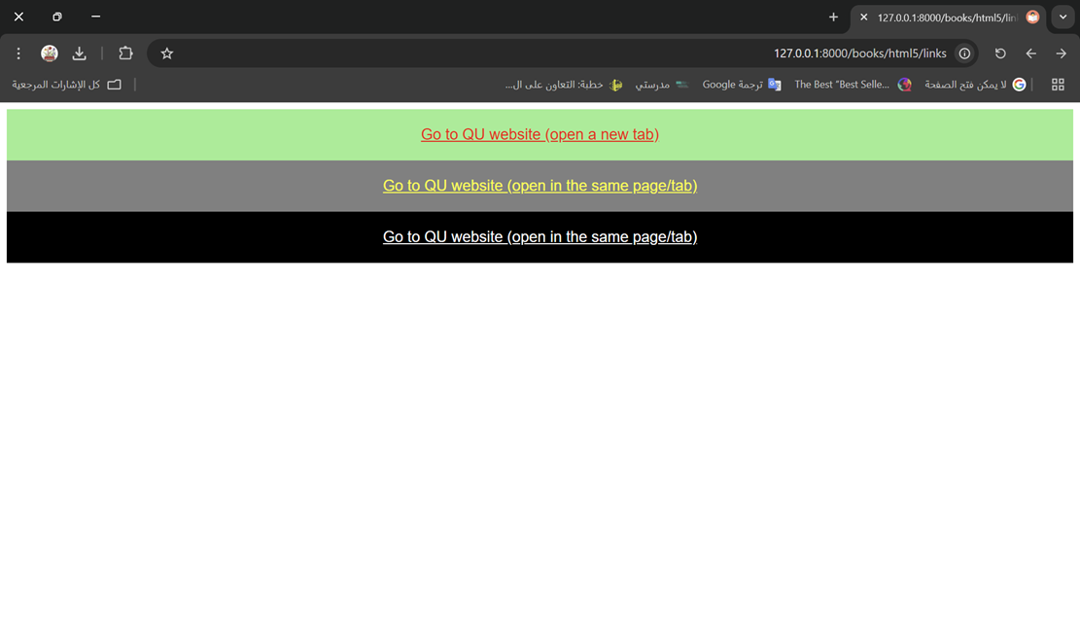

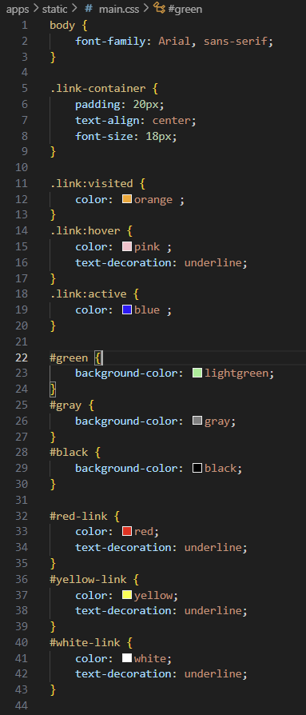

**Task 2:**

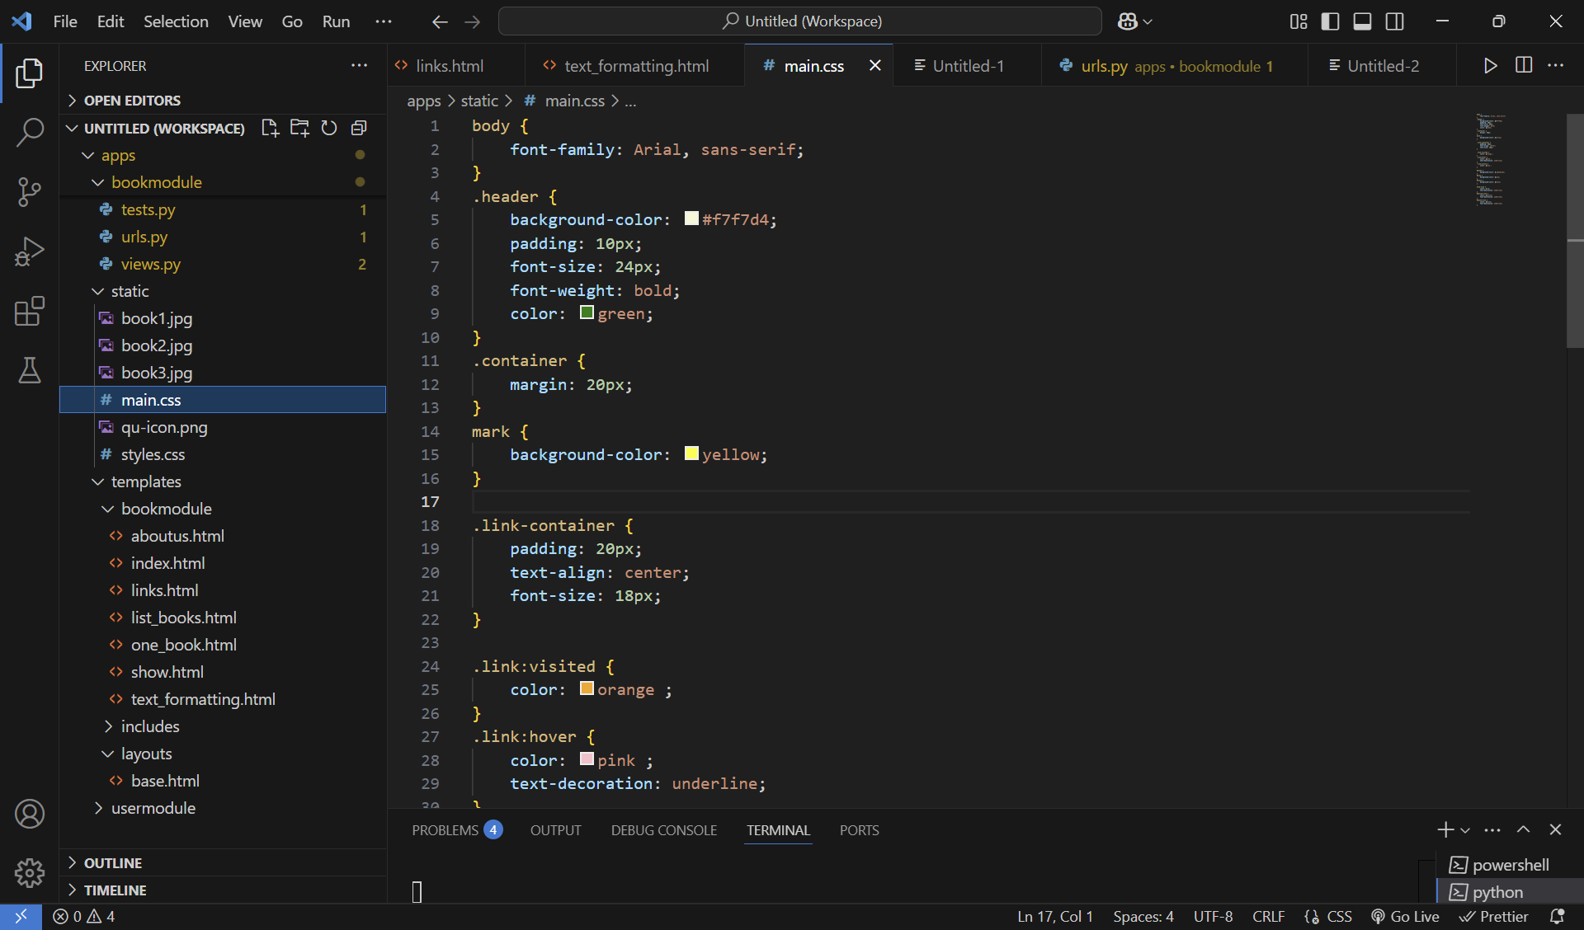

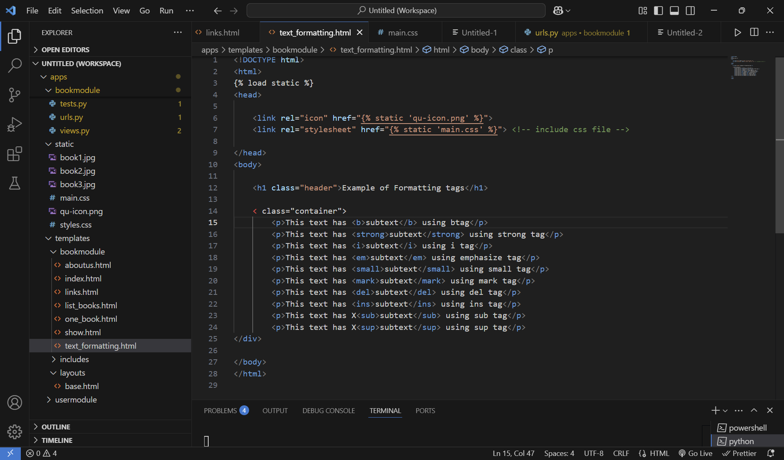

**Task 3:**

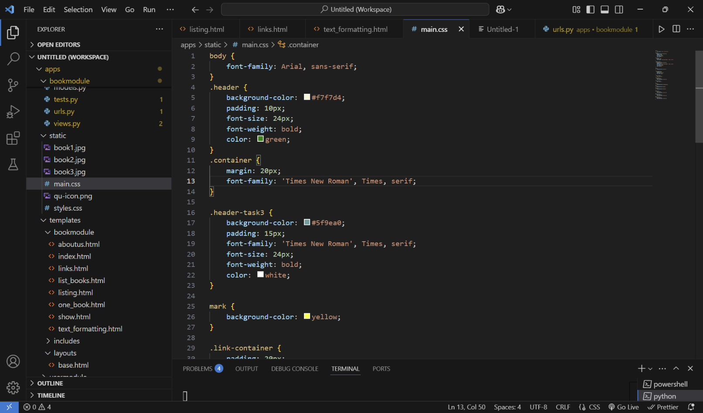  
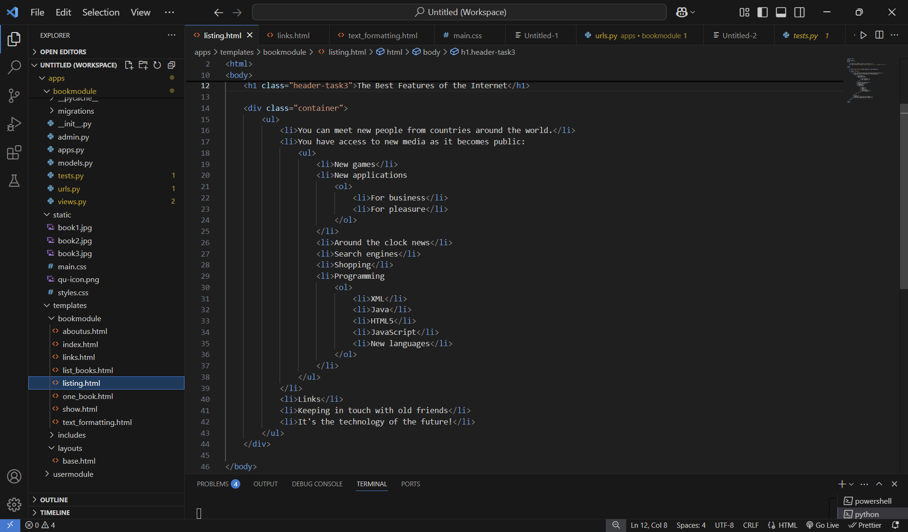

**Task 4:**

